Experiment -5 – Building a war file in Devops

1. Use the Jenkins Server created in experiment 2
2. Ensure Jenkins is running by opening http://<IP address:8080/
3. Login using admin/admin credentials
4. Go to Manage Jenkins and then go to plugins, search for Maven Integration Plugin and install the plugin.
5. Now create a job in Jenkins by clicking New Item,
6. Give a name to the job
7. Select maven project and click ok.
8. Go to Source Code Management and select Git, give the github url of your Maven project that you created in experiment2.
9. Go to Build, and give the below command under Goals and Options: clean install package.
10. Click on Apply and Save
11. Click on Build Now option, available on the newly created job.
12. Build will start in few seconds and should give you Build success and the war package must be created. You can check the output under Builds> #1, right click and see console output, view as plain text. It will also show the location of the war file where it is created.

/var/lib/jenkins/workspace/Buildwar28feb/target

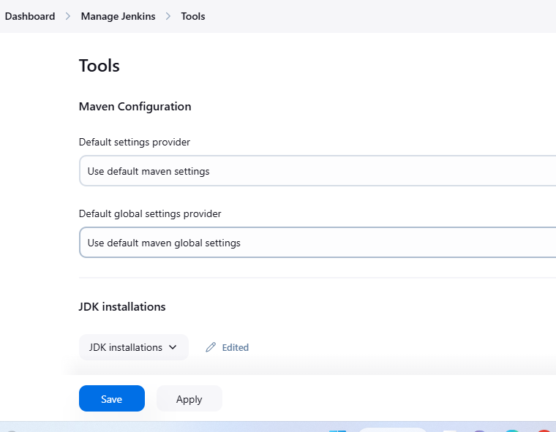

Ensure Java home is set in PATH variable:

